**Building Dynamic Frontend Components For Marketplace - Furniro**

**Brand Name:** Furniro

**Theme**: A focus on modern, vibrant, and stylish furniture collections, emphasizing contemporary home decor.

**Key Components:**

Product Listing Component:

**Source code snippet:**

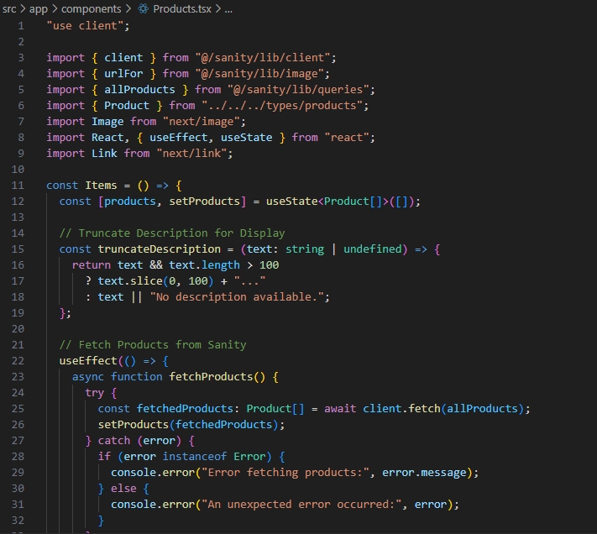

**Output Snippet:**

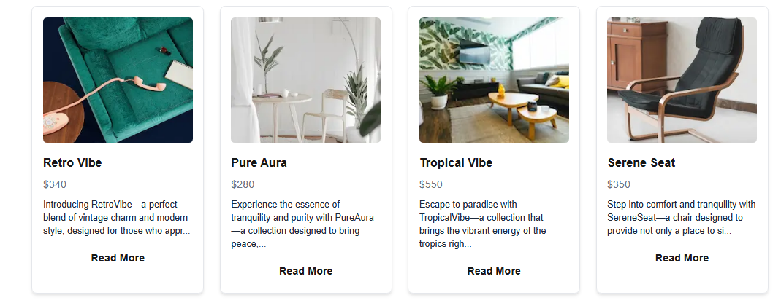

Product Detail Component:

**Source code snippet:**

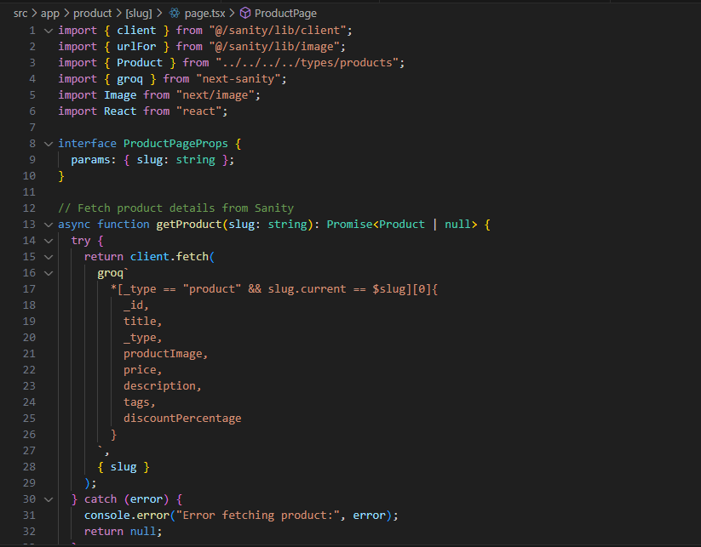

**Output Snippet:**

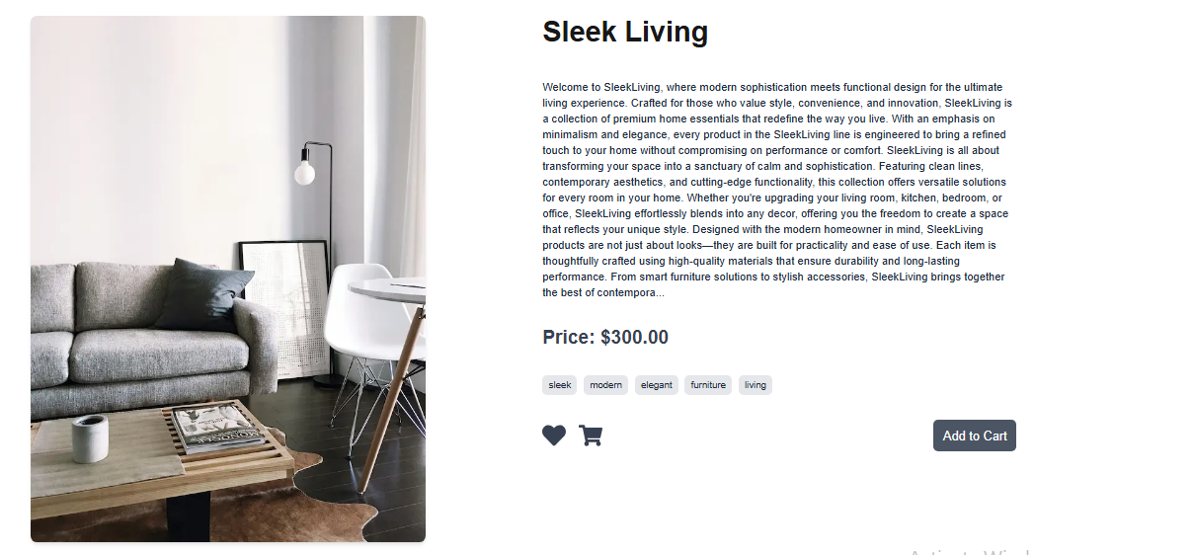

Category Component:

**Source code snippet:**

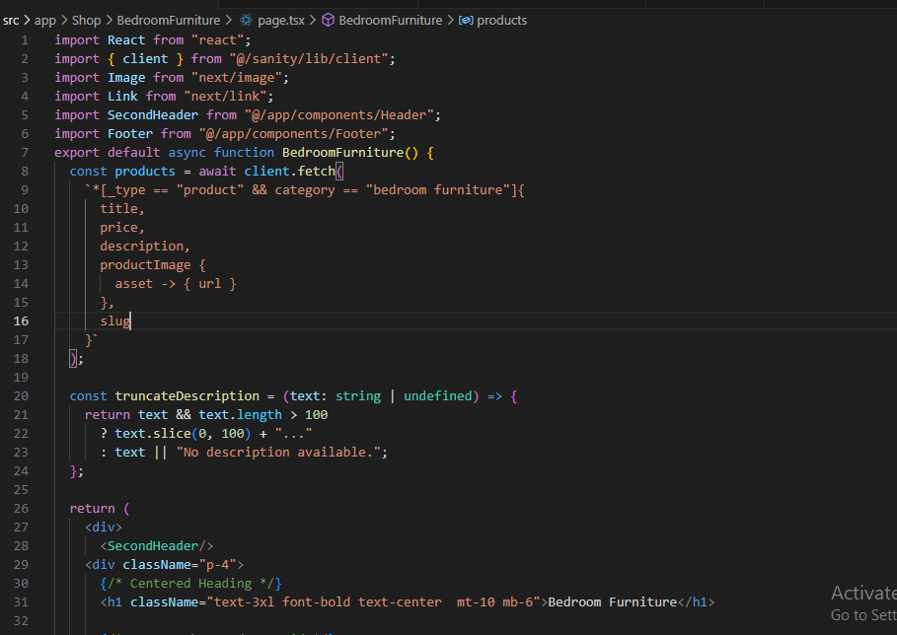

**Output Snippet:**



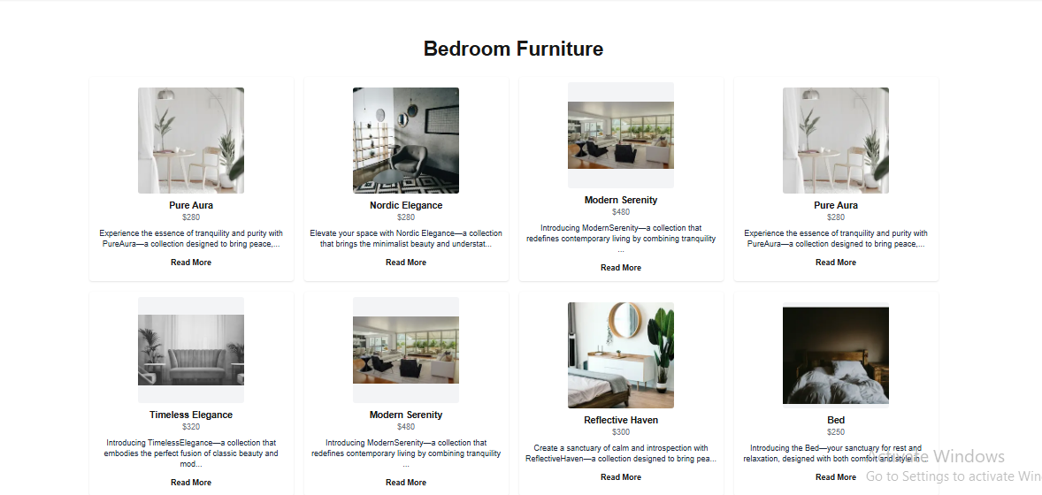

Search Bar:

**Source code snippet:**

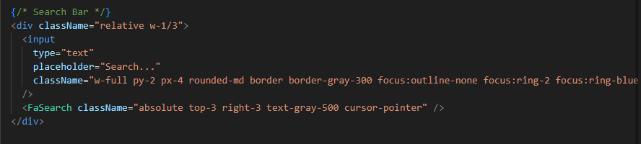

**Output Snippet:**



Cart Component:

**Source code snippet:**

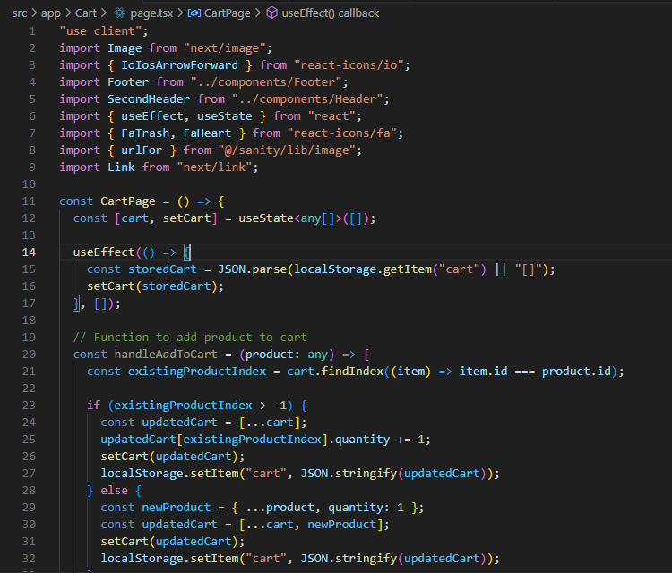

**Output Snippet:**

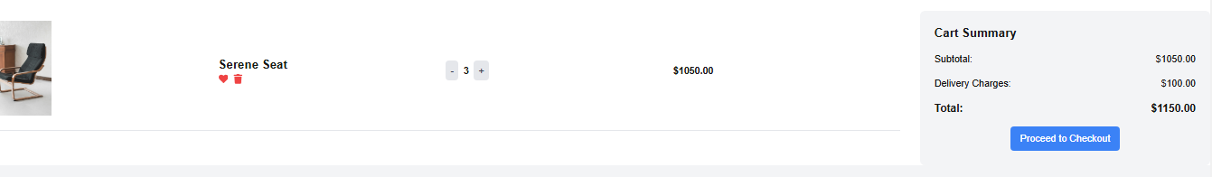

Checkout Flow Component:

**Source code snippet:**

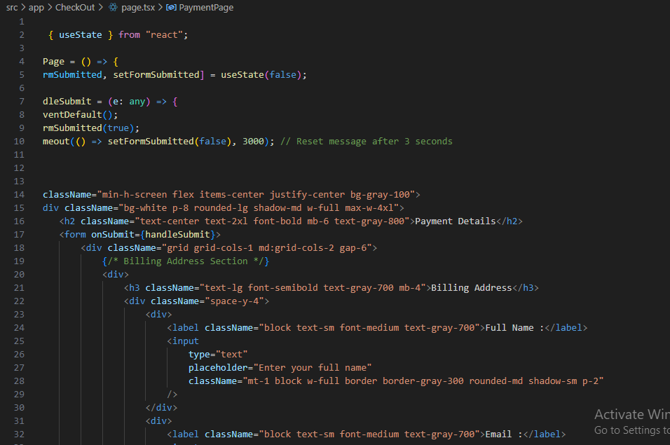

**Output Snippet:**

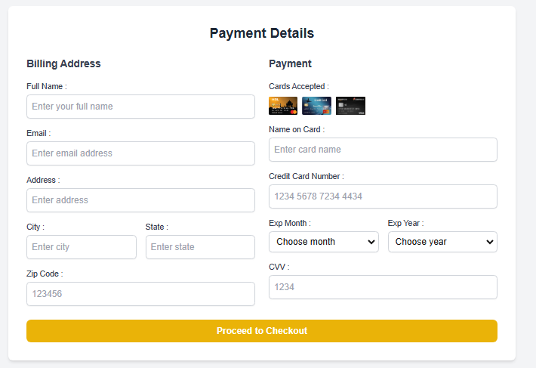

Footer and Header Components:

**Source code snippet:**

Header:

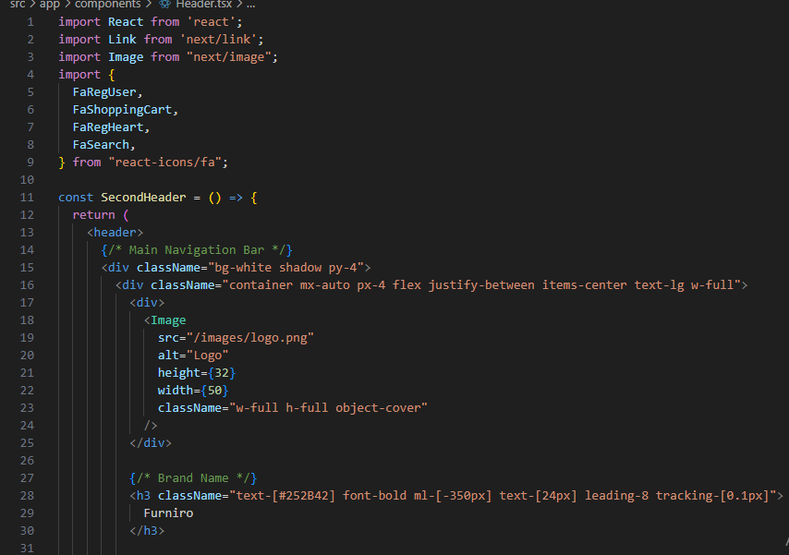

Footer:

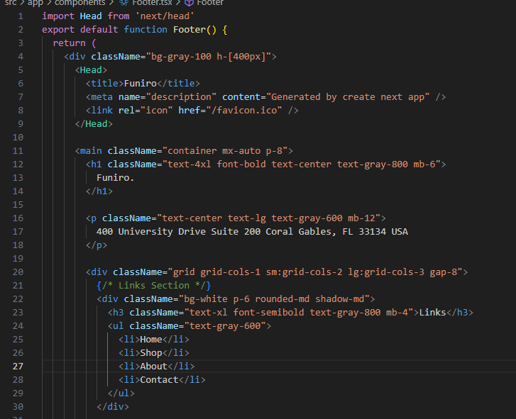

**Output Snippet:**

Header:



Footer:

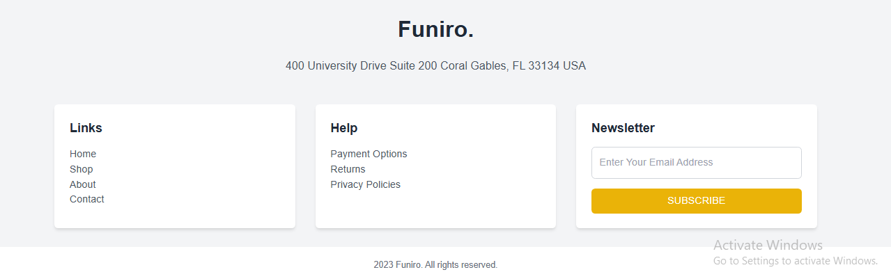

FAQ and Help Center Component:

**Source code snippet:**

**Output Snippet:**

API Integration:

* Sanity API Fetching Process: As you are utilizing Sanity CMS, make sure the data fetching is handled appropriately.
* Sanity Client Configuration (if not already implemented): Set up the Sanity client in your lib folder for API integration.

Dynamic Routing:

* Dynamic routing is employed to manage routes such as /Product/[slug] for individual product pages.
* Create a Dynamic Route File: Inside the app directory, create a [slug] folder then page.tsx file within the product folder:
* Get Product Data Dynamically:

Final Check List:

* Frontend Component Development
* Styling and Responsiveness
* Code Quality
* Documentation and Submission
* Final Review